* **ORM (Object Relational Mapping)**

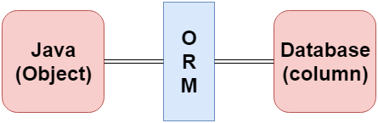

* Frameworks that function on ORM mechanism: -
  + Hibernate
  + TopLink
  + ORMLite
  + iBATIS
  + JPOX
* **Reference**

<https://www.javatpoint.com/jpa-object-relational-mapping>